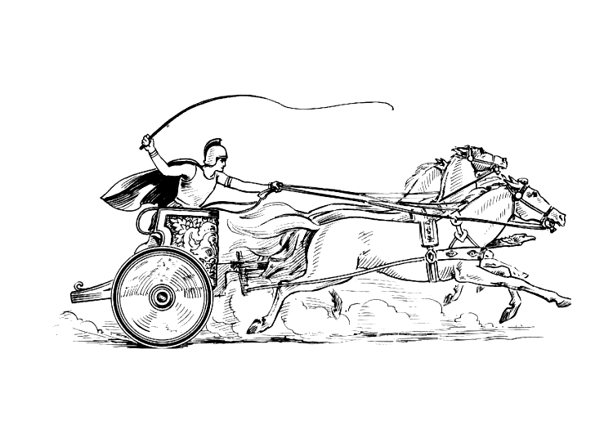Manduessedum - Mancetter Village (Place of War Chariots)
Mancetter Parish Council
Serving the People of Mancetter and Ridge Lane

You are invited to the Mancetter Parish Council Meeting
being held in the Schoolroom of St Peter’s Church Mancetter
on Tuesday 22nd July 2025 at 7pm.

AGENDA

- Welcome and Apologies.

- Chairman’s request that anyone recording the meeting make themselves known, to allow
for openness and recognise practicalities. An audio recording of the meeting will be
made by the Council, and will be deleted upon production of the draft minutes.

- Declared Notice of Interest by Councillors concerning Agenda items.

- Public Question time of up to 15 Minutes for Parishioners to raise issues.

- Police, County and Borough Councillor feedback.

- Minutes of the last meeting.

- To accept the draft minutes of the Parish Council Meeting held on 27th May 2025.

- Matters Arising from the meeting on 27th May 2025

- To facilitate improved Councillor communication and updates between meetings, the
council is asked to consider holding an informal “Councillor Catch Up” session on a Thursday Morning between 10am and 11am at Mancetter Memorial Hall on a pre-arranged date in February, June, August, October and December.

- Finance

- Signing of all payments in accordance with standing orders, financial regulations and the bank mandate.
- To receive an update on Mancetter Parish Council finances for the first quarter of this financial year, April – June 2025.
- To approve a transfer between budget headings in relation to staff and contractors.
- To review forthcoming changes to HSBC Accounts and discuss implications. This relates to Interest Rates, Bank Charges and the abolition of physical Security Devices.
- To note that CCLA has merged with another financial provider.
- To re-consider a written request for Financial Assistance from Bee Line Community Transport.
- To note the allocation of reserves to Grant Funding, Traffic Calming and Neighbourhood Plan Reviews, and if necessary authorise any amendments.

10 Feedback from meetings, events and training attended since 27th May 2025

- Developing a Local Nature Action Plan – 6th June 2025
- North Warwickshire Town & Parish Councils Area Committee – 12th June 2025
- WCC Solar Energy Teams Meeting – 13th June 2025
- Wathen Grange Developer Meeting – 17th June 2025
- Mancetter Quarry Liaision Meeting – 7th July 2025
- WCC Devolution Zoom Meeting – 8th July 2025
- Warwickshire Town & Parish Councils Reference Group – 15th July 2025
- Neighbourhood Plan Steering Group – 18th July 2025

11 Cemetery and Maintenance around the Parish

- Update on contract work for digitalising cemetery records. To review progress and consider future requirements.
- To consider the introduction of a separate admin fee to process additional workload created by direct cremations that do not involve a funeral director.

- Planning Matters and New Applications since the previous meeting

- Update on Approved, Rejected, Pending Applications, Enforcement Issues and Appeals.

PAP/2024/0154 & 0160 Greenacres, Nuneaton Road Mancetter - Pending
PAP/2024/0186 Kirby Glebe Farm, Atherstone Road, Hartshill - Pending
NWB/24CM013 Tarmac Quarry County Council Minerals Application- Pending
PAP/2024/0538 Barn Fishery Atherstone Road Hartshill - Pending
PAP/2025/0174 Watling Street Motors – Stateside Autoparts Watling Street Mancetter – Granted
PAP/2025/0175 Watling Street Motors – Stateside Autoparts Watling Street Mancetter – Granted
PAP/2025/0162 The Rothen Group – Mancetter Marina - Granted

CMP/2025/00072 Signage relating to hot food van Manor Road Mancetter
CMP/2025/00078 Siting of Hot Food Van.

- To discuss any new applications received.

- PAP/2025/0280 – 124 Ridge Lane – Demolishment of porch and and new front single storey extension.
- PAP/2025/0290 – 32 The Spinney – Removal of an Ash Tree with TPO.

- To consider attending additional planning training sessions on 14th and 21st October 6.30pm – 8.30pm on Zoom. Dealing with Development Proposals is session one and Influencing local plan policies the following week.

13 Date of next meeting- Wednesday 17th September 2025 7pm at Ridge Lane Chapel and Community Room.

Signed 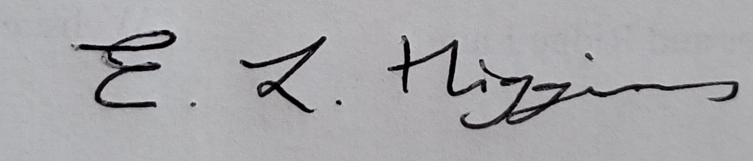
Date 16th July 2025.
Elane Higgins
Parish Clerk Mancetter Memorial Hall Old Farm Road Mancetter CV9 1QN
Tel: 01827 722552 / 07368 265051
Email: parishclerk@mancetterparishcouncil.gov.uk
Website: www.mancetterparishcouncil.gov.uk

